**EXP-12:**

**Aim:** To Design Deterministic Finite Automata using simulator to accept the input string “a” ,”ac”, and ”bac”.

**Diagram:**

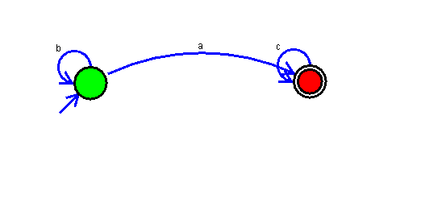

**Result:**

Successfully executed Deterministic Finite Automata using simulator to accept the input string “a” ,”ac”, and ”bac”.